**Cesium**

Cesium is effective for the rendering of the simulated flight in the Unreal Engine of an airplane over the surface of planet Earth. It provides enough detail to be realistic from a reasonable height. Cesium ion is run through a server called CesiumIonSaaS that stores and streams the geospatial data. This includes the entire Earth’s surface but detail is flattened in most areas outside of cities. There are certain areas that include a deeper level of detail including an enhanced street view and other details such as night-time details (Cesium 2023).

**Figure 1**

*Chicago in Unreal using Cesium*

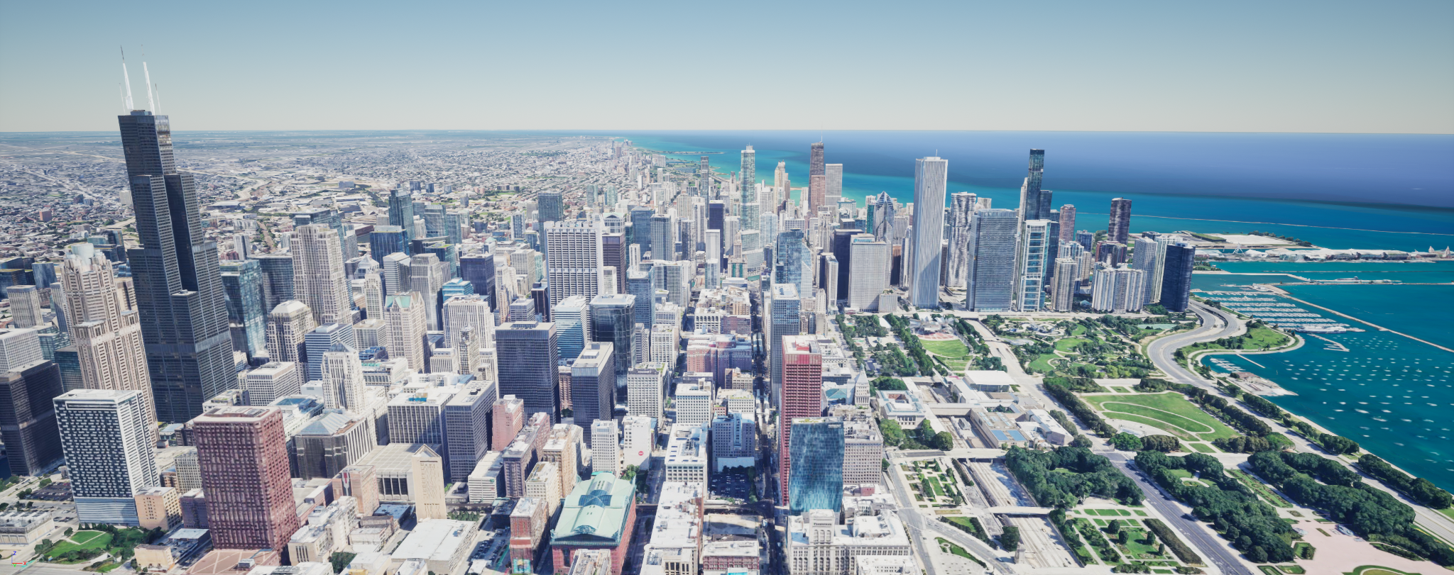

Some areas on Cesium’s Asset Depot include Denver, San Francisco, the Arctic, Melbourne, Montreal, Boston, Washington D.C., and Washington State. These include some enhanced quality on particularly historic buildings (Cesium 2023).

**Figure 2**

*Enhanced Models*

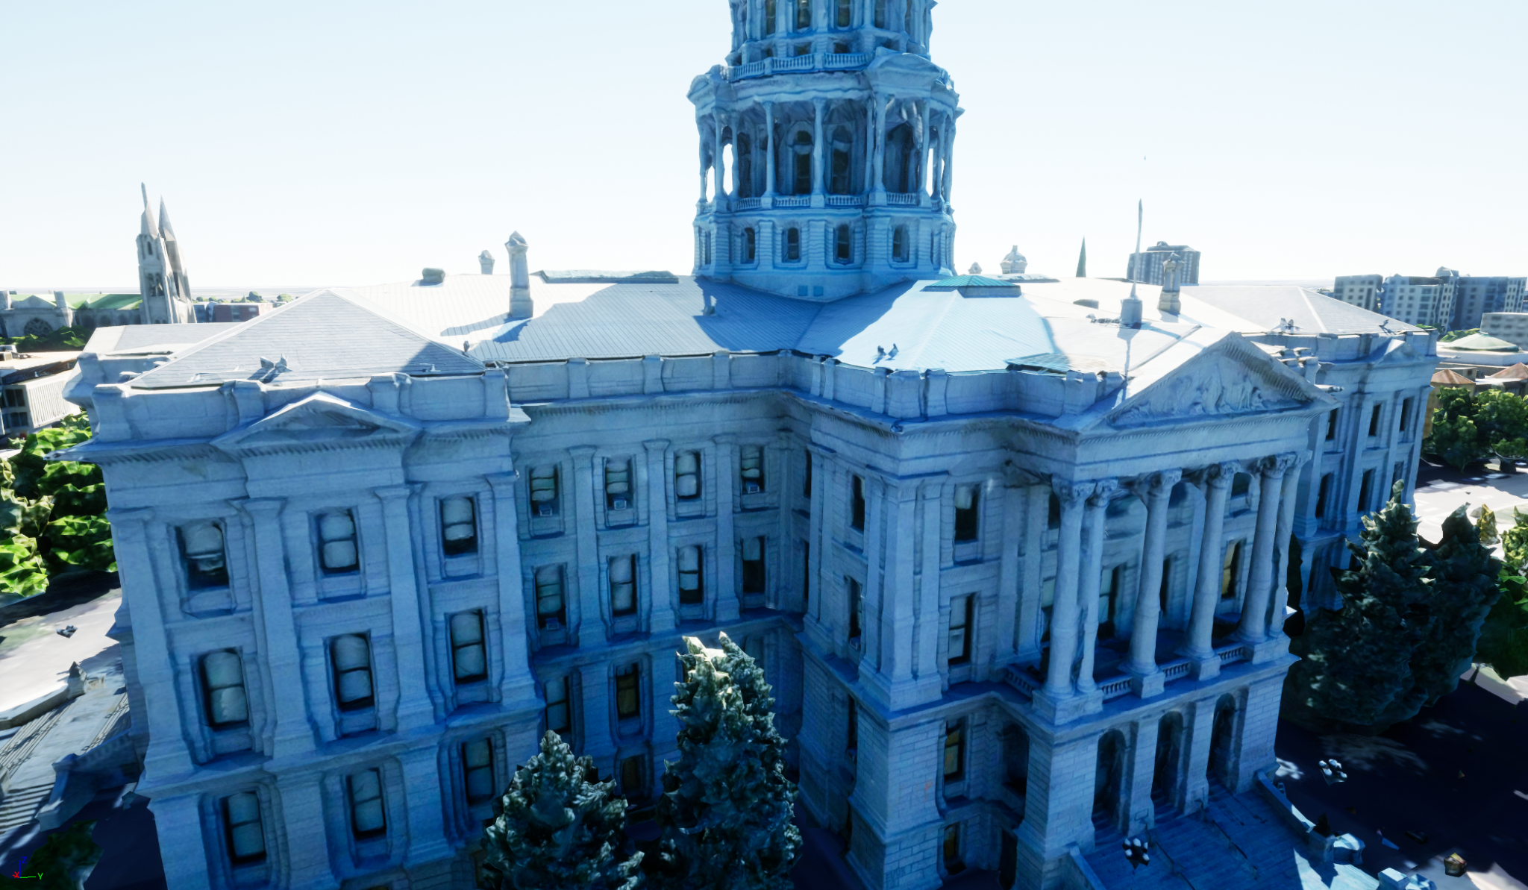

Use of Cesium assets is optimal at medium-high altitudes due to a few factors that affect the quality of the generated materials.

**Figure 3**

*Close Quality*

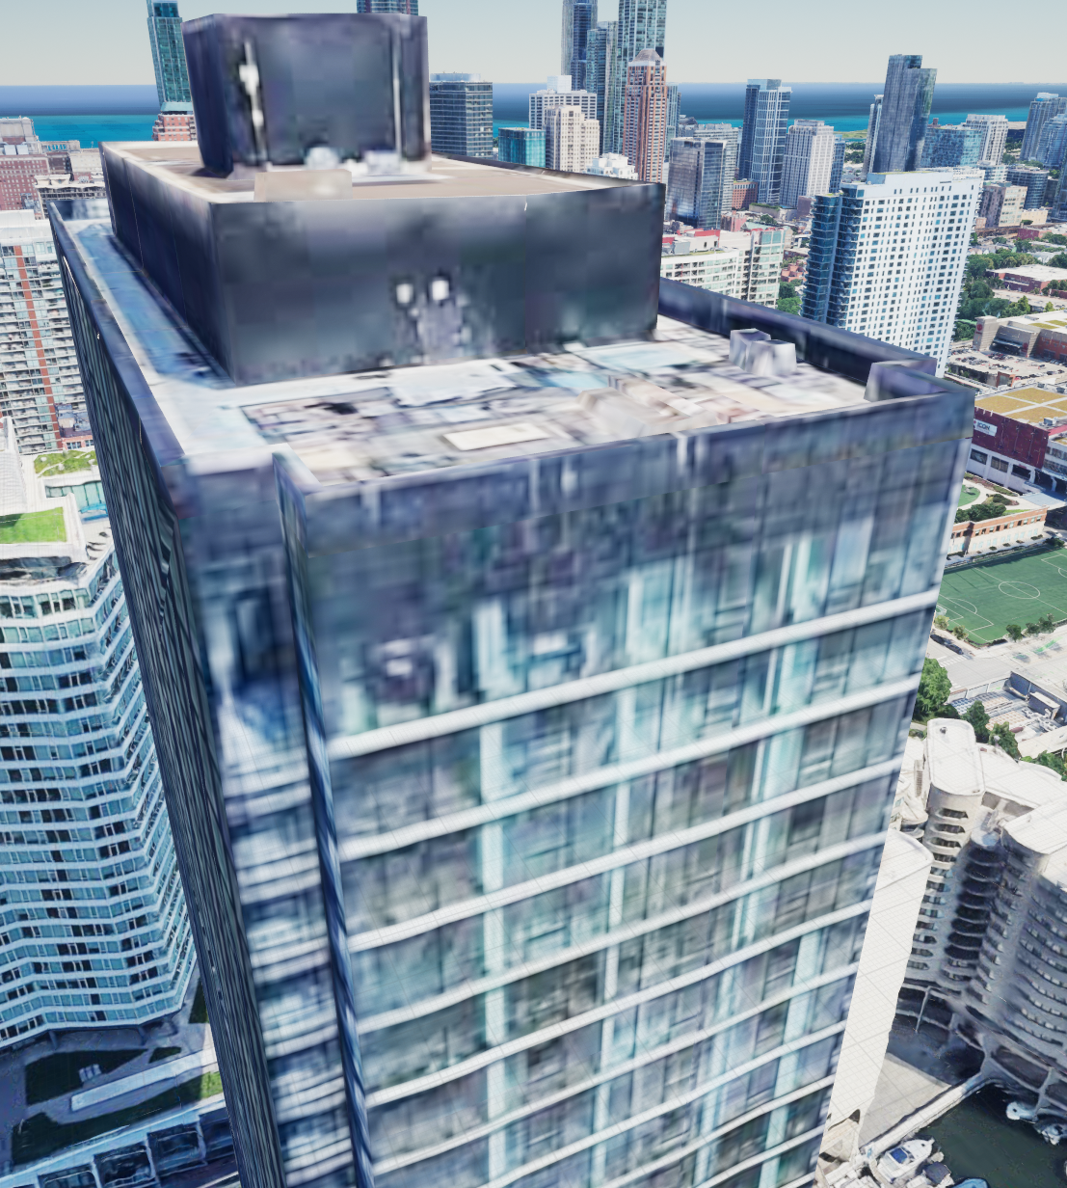

The data analysis causes vehicles and some trees to merge with the ground and some objects will have floating artifacts.

**Figure 4**

*Floating artifacts*

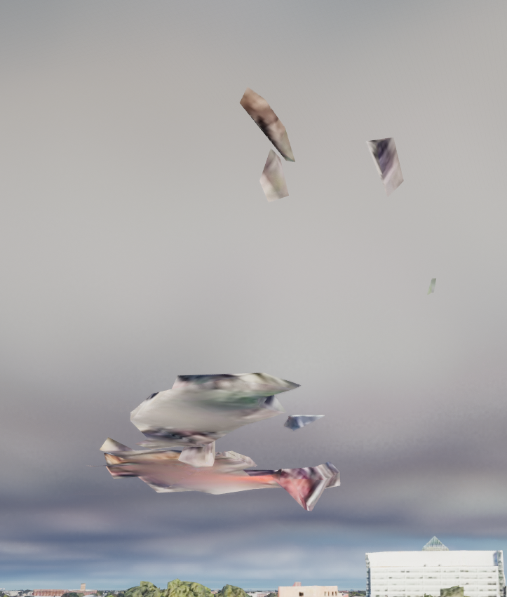

Highly reflective surfaces will warp the shape of the object it is a part of.

**Figure 5**

*Reflective Surfaces*

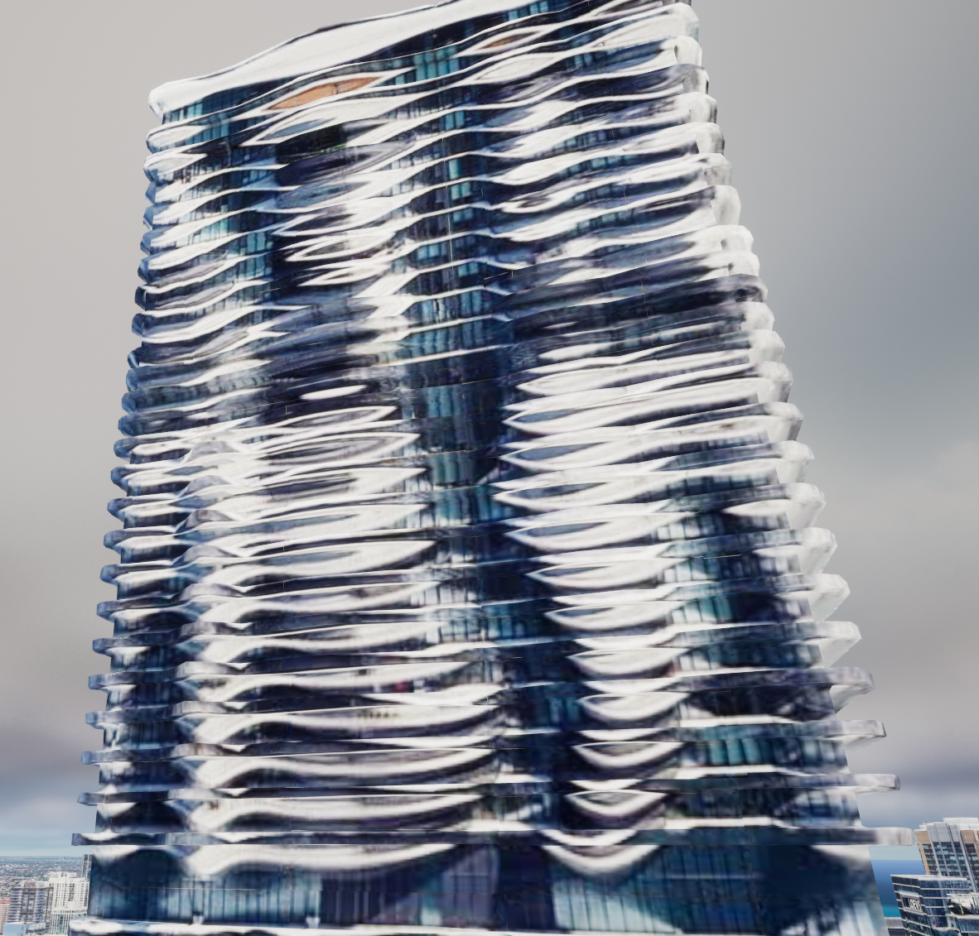

**Sublevels**

Sublevels with added assets can be created to quickly swap between areas of the globe with the ‘CesiumFlyTo’ component attached to the DynamicPawn. Added assets may cause shadows cast on the opposite side of Cesium geometry (Cesium 2023).

**Figure 6**

*Shadow error on added assets*

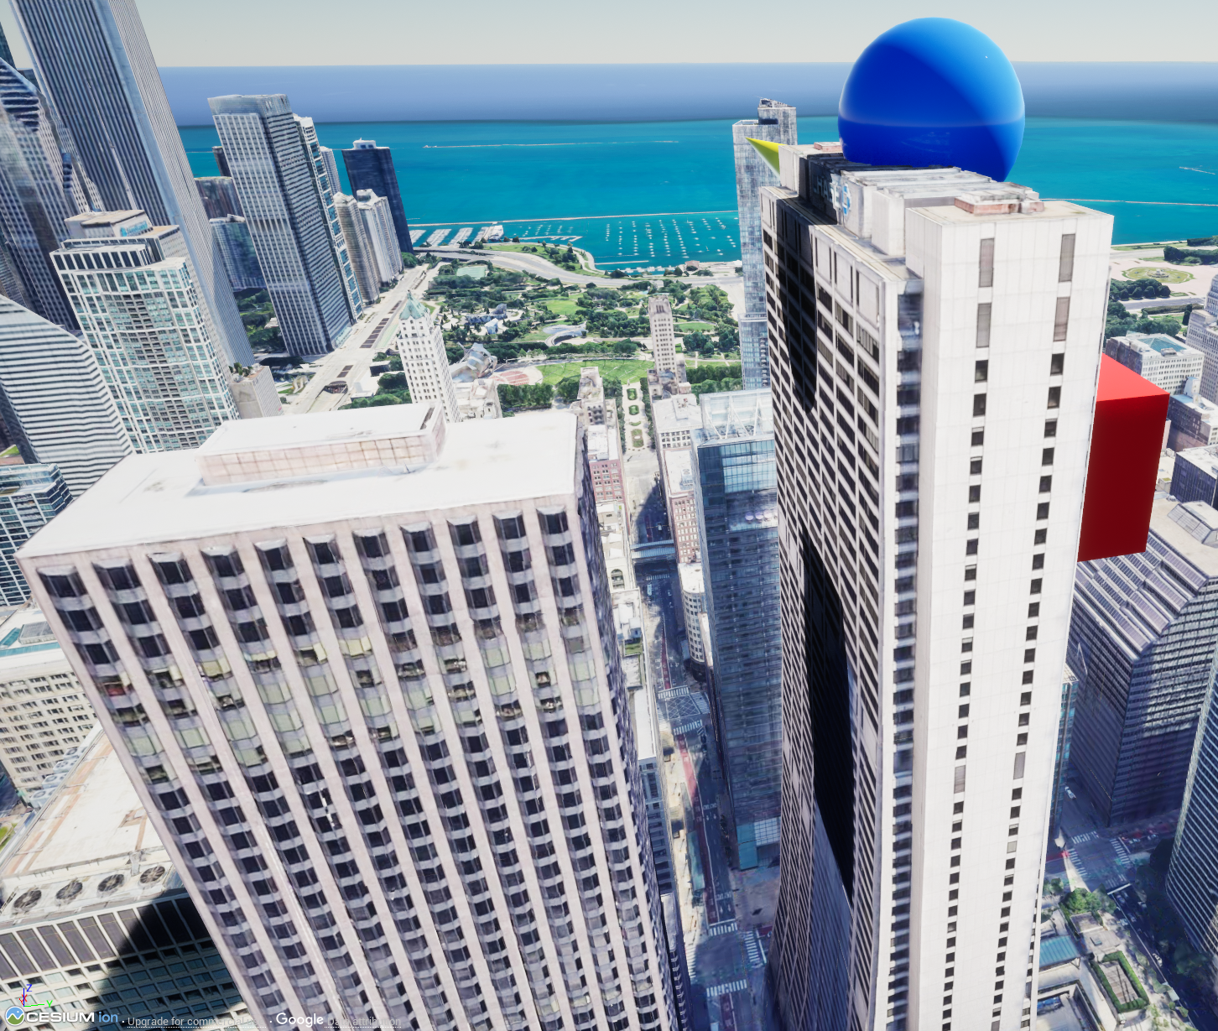

The user can customize their flight path among curves between global points to traverse smoothly with blueprints. “Fly to Location Longitude Latitude Height” requires a float input for Pitch and Yaw, a vector for Longitude, Latitude, and Height at the Destination, a target “Fly To” component, and a boolean for “can interrupt by moving”“Fly to Location Unreal”, “Interrupt Flight”. Curve objects can be made to customize the flight path, duration, and transitions. In the context of a flight simulator, this can give the user a variety of options to traverse to intricately detailed city scenes that they can explore and jump between at will (Cesium 2023).

**Google Photorealistic 3D Tiles**

Google Photorealistic 3D Tiles can allow someone to navigate anywhere on Earth but the scale poses an issue. This research found the optimal adjustment to navigate the Earth was to scale the camera speed in the viewport to its maximum and start the camera speed scale at 7x. Once a user is close to the specific region that they would like to view closer, they can reduce the scale gradually down to 1 depending on range. This is preferable to scaling down the size of the Earth due to some issues that show grid lines and objects that obscure the camera view. When scaled, there is no noticeable difference in the quality of the details.

**Figure 7**

*Grid Lines*

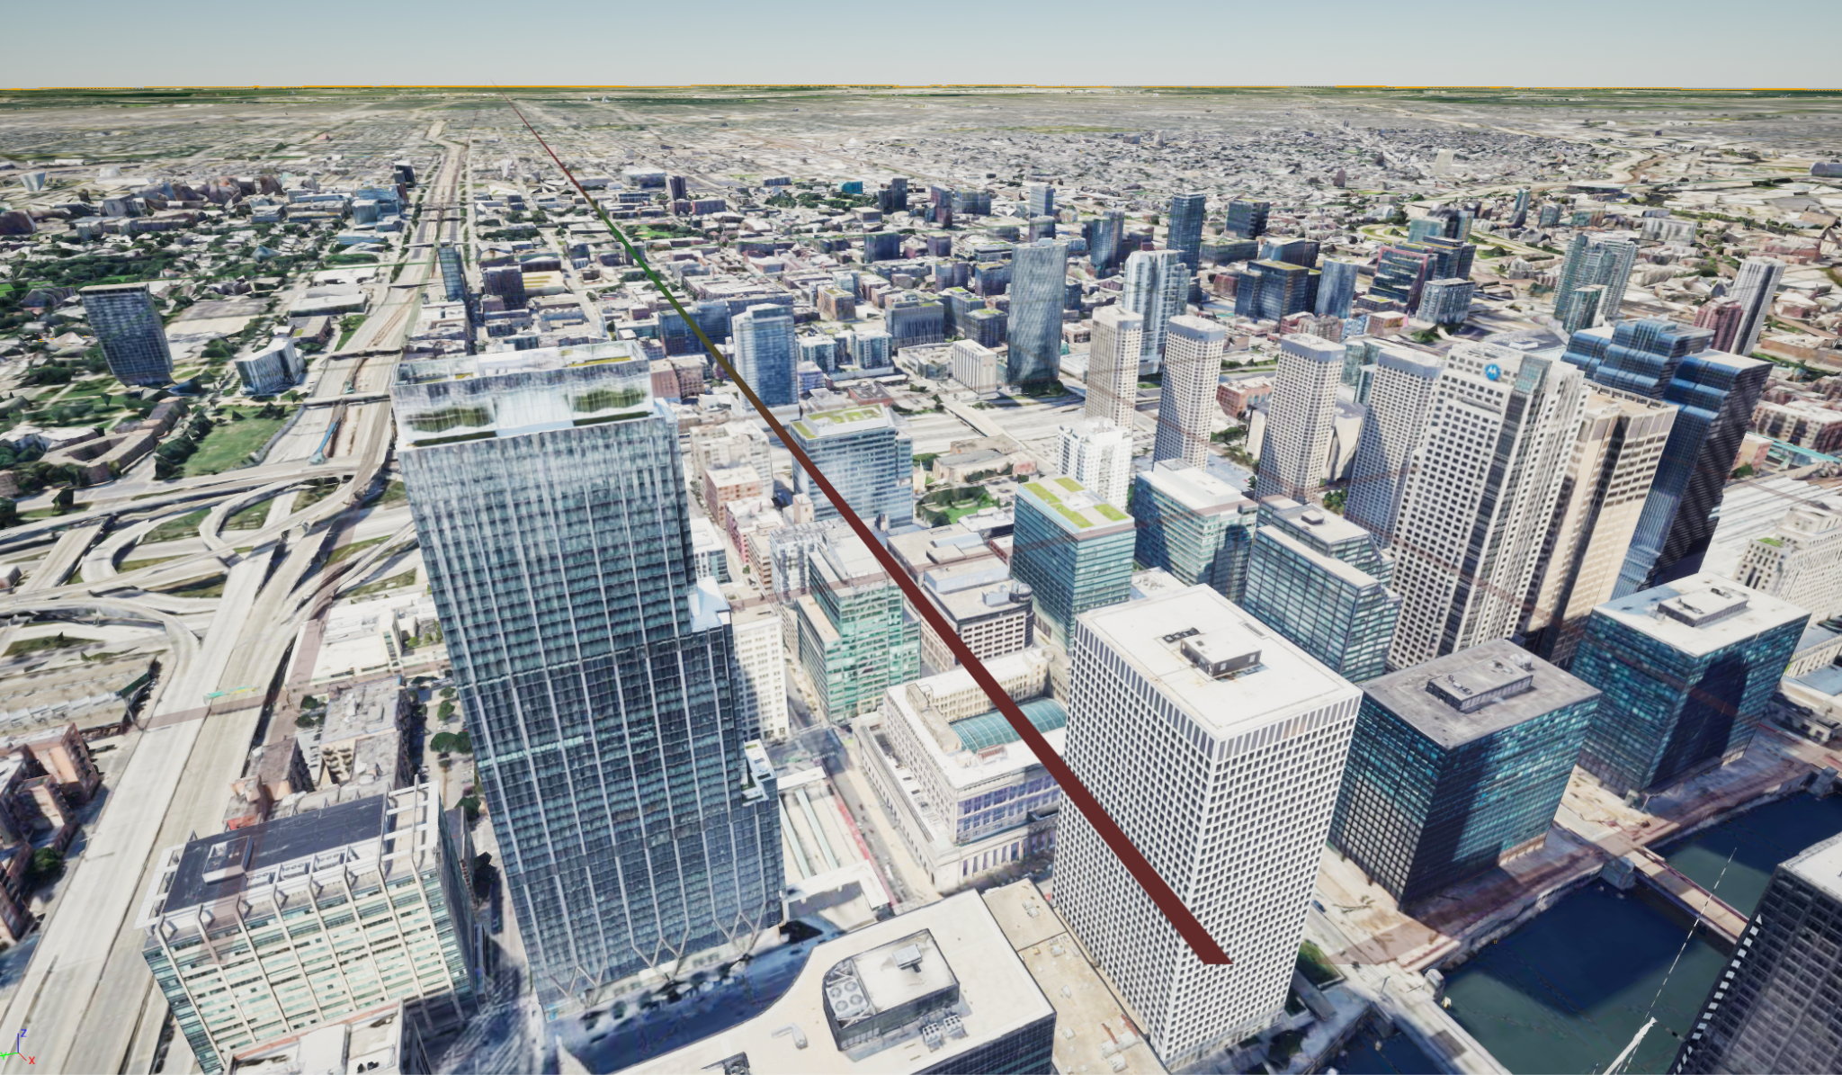

The planet’s surface will appear slanted the further away from the level georeference origin point. This can be corrected by hitting the ‘Place Georeference origin here’ button in the settings panel with ‘Google Photorealistic 3D Tiles’ selected. Errors occasionally occur on the map where a tile will be transparent (Cesium 2023).

**Figure 8**

*Tile Error*

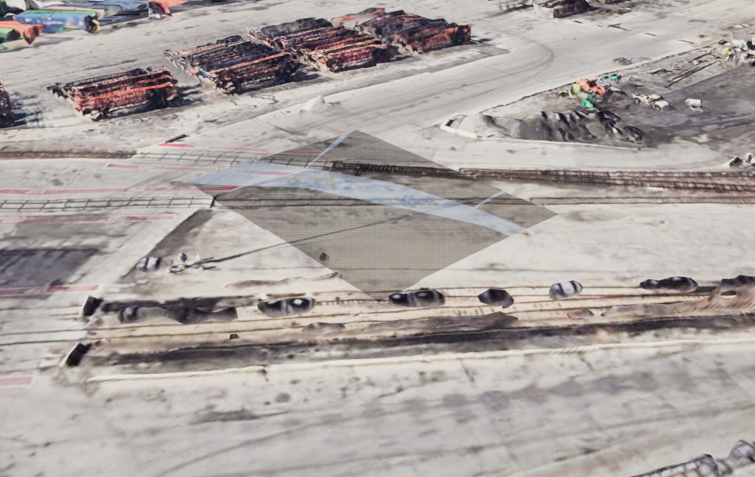

Highly populated areas have 3D building data, rural areas do not. Planning the flightpath of your simulation will be assisted by keeping this in mind to be at a significant height by the time you reach these flattened areas. An alternative to this would be covering the flattened images with appropriate models (Cesium 2023).

**Figure 9**

*Flat rural*

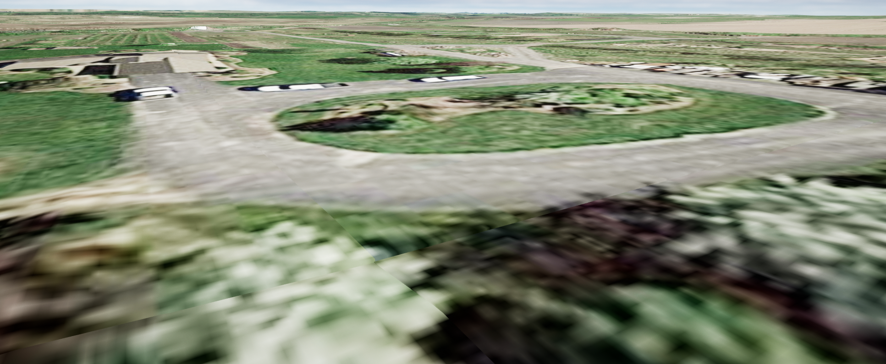

**Level of Detail**

The level of detail is dependent on the setting for Maximum Screen Space Error in the ‘Google Photorealistic 3D Tiles’ settings. Setting this too low or too high both have drawbacks. The lower the setting is, the more detail you will get on the areas further away from the camera. This is a memory limitation and all areas outside of the view of the camera are culled by default. With this setting, it can cause the models and textures to ‘pop in’ as they load when you rotate the camera. A higher setting can quicken the time it takes to load in details but you will lose details far away from the camera. Depending on the user’s hardware, numbers as low as 2 can cause the engine to crash based on memory limitations. Research found a setting of 4 had a load time of roughly 60 seconds when turning the camera in the dense urban environment of downtown Chicago. At a setting of 64, there were no visible loading details (Cesium 2023).

**Figure 10**

*Maximum Screen Space Error Settings 4, 64*

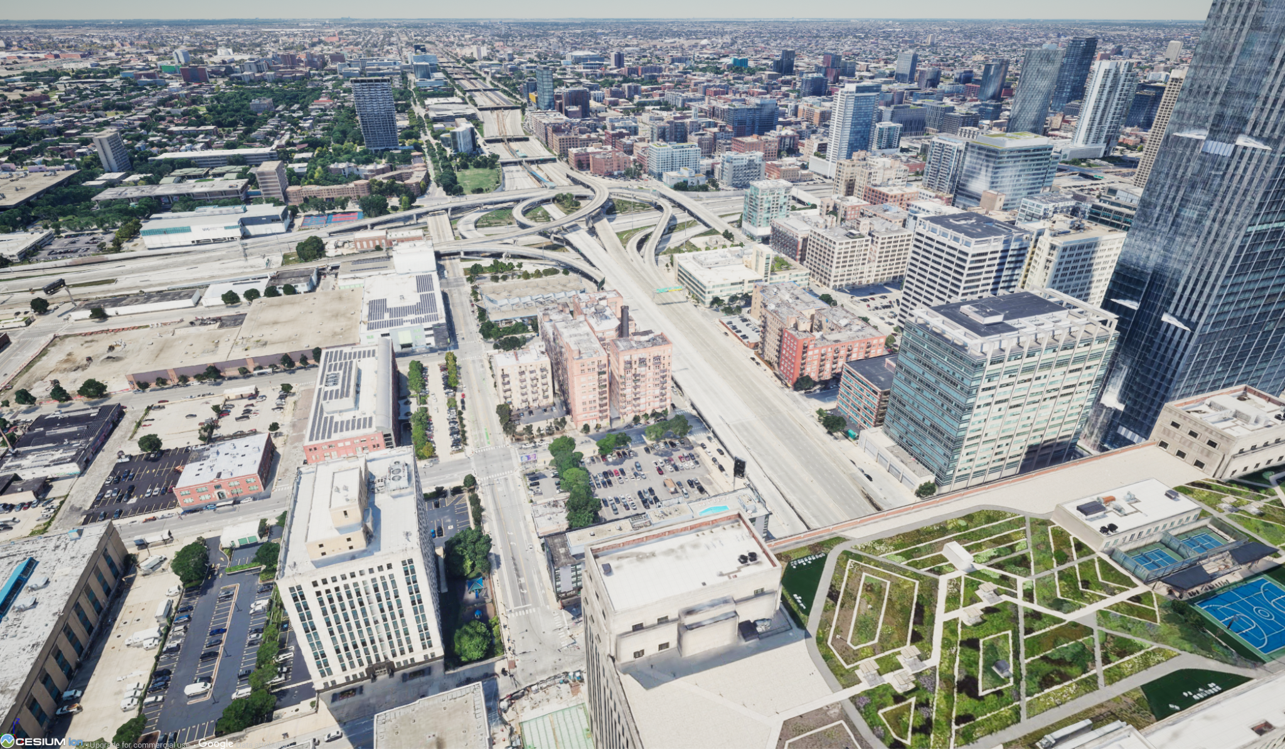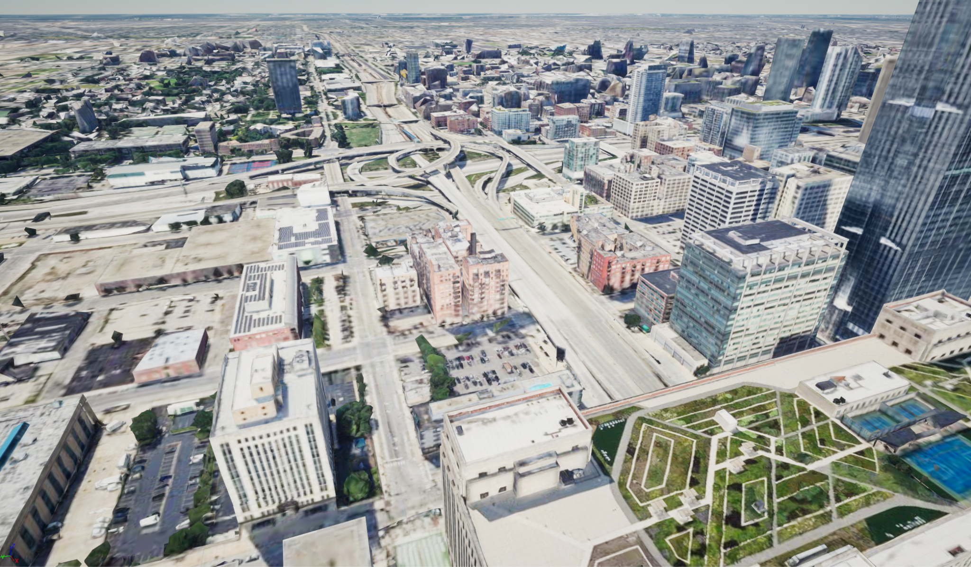

*Note.* Level of Detail far from the camera degrades as the MSSE setting is set higher

Enforce Culled Screen Space Error’ is a boolean setting that allows for the selective culling of tiles outside the frustrum of the camera or hidden in fog. This can be useful for maintaining physics and shadows on objects outside of the frustrum at the cost of consuming more resources. The culling of tiles obscured by fog can be enabled or disabled by the boolean setting: ‘Enable Fog Cull’. ‘Forbid Holes’ is a boolean setting that will restrict the engine from loading a child tile that has not been loaded yet and will revert to its parent tile instead of leaving a blank spot in the area. This can improve performance but causes details to pop in. The setting for ‘Maximum Cached Bytes’ is a setting that determines when tiles that are not necessary for loading will be unloaded. The boolean setting ‘Enable Frustrum Culling’ could be useful for a more consistent physics simulation. ‘Enable Occlusion Culling’ is a boolean setting that could increase performance in areas with a large amount of occlusion but unnecessary overhead in areas that do not. The ‘Occlusion Pool Size’ determines the number of components to use during the occlusion query. ‘Delay Refinement for Occlusion’ can cause some delays before tiles appear but improve performance costs due to avoiding load of occluded descendants. ‘Create Physics Meshes’ is a boolean setting that can improve performance when disabled if any actors will not collide with objects in the scene (Cesium 2023).

**Cesium Sunsky**

A tool is included with Cesium that applies natural light in the scene. Similarly to global lighting, Cesium Sunsky can be rotated to affect the time of day. However, some light flickering will occur during times at dusk and early morning.

**Figure 11**

*Dusk Flickering*

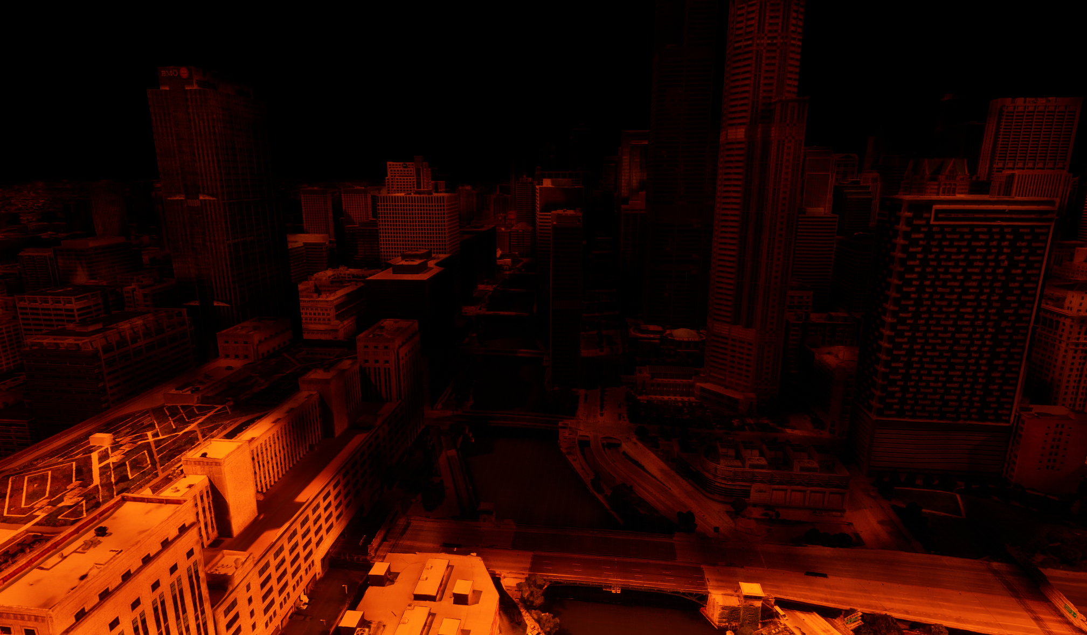

**Cesium Georeference** -

The latitude and longitude of locations on Earth can be input here to jump to that location

The Georeference is an actor within a Cesium level that relates to the coordinate system for the selected actor. These georeferences are automatically generated if none already exist and can be accessed through blueprints using “Get Georeference”. “Apply DPI Scaling” is an option for high DPI screens and mobile devices to improve performance. Rotation (East-South-Up) - Use Roll to adjust Sun position (time of day) - Give some time for light to populate. Sunset can cause certain lighting issues. Swapping to daytime will oversaturate with light. Rotate the camera to adjust. The latitude and longitude of locations on Earth can be input here to jump to that location (Cesium 2023).

**Cloud Generation**